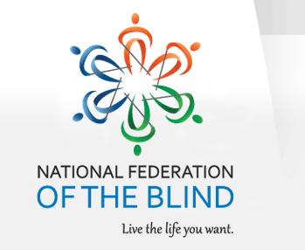

The National Federation of the Blind of Florida is now accepting student scholarship applications for 2026 in recognition of their achievements and professional aspirations. Recipients will receive their scholarships at the 2026 Annual State convention scheduled for the weekend of Friday, October 9th through Sunday, October 11th in Jacksonville, Florida. Recipients of the scholarship will have their expenses covered by the Florida Affiliate to attend the State Convention: including travel to and from the convention, hotel room, a daily stipend, registration and banquet.
Qualified high school seniors and college students must complete the scholarship application form in MS word format, write a 500-word essay, provide two letters of recommendation, proof of blindness, and submit their academic transcripts.
All documentation must be return to:
Jorge Hernandez, Chair
NFBF Scholarship Committee
Email: scholarships@nfbflorida.org
Telephone: (305) 877-2311

The National Federation of the Blind of Florida will be awarding scholarships, each in the amount of $1,500 at the National Federation of the Blind of Florida annual convention banquet on Sunday evening, October 11, 2026. Two scholarships will be awarded to students who are deaf-blind.
Completed applications are due no later than August 15, 2026, at 11:59 p.m.
For your convenience, the scholarship application, scholarship checklist, and scholarship guidelines are attached to this correspondence.
For more information you can contact the scholarship chair, Jorge Hernandez via Email or mobile number located in this correspondence.

Sincerely,

Jorge Hernandez, Scholarship Chair
National Federation of the blind of Florida

